INSTALLING NODEJS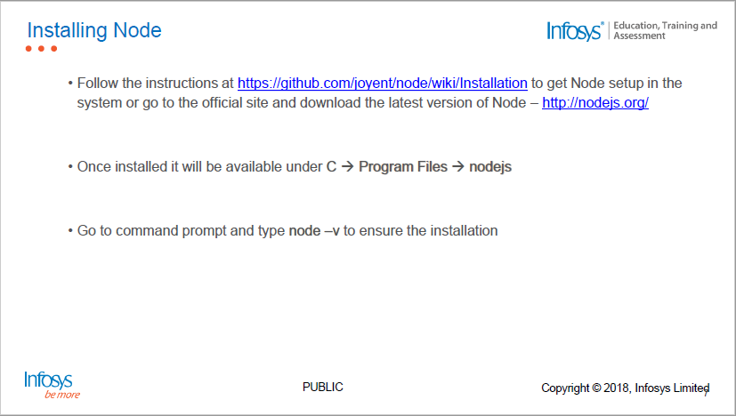

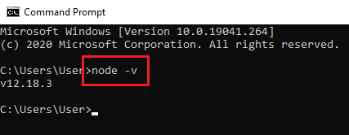

Mongo db:

* Mongo DB Website: <https://www.mongodb.com/>
* Step 1: Download Link: <https://www.mongodb.com/try/download/community?tck=docs_server>

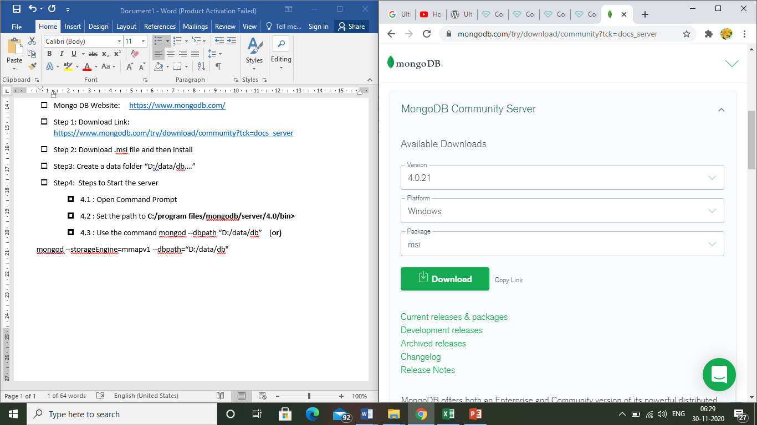

* Step 2: Download .msi file and then install
* Step3: Create a data folder “D:/data/db….”
* Step4: Steps to Start the server
  + 4.1 : Open Command Prompt
  + 4.2 : Set the path to **C:/program files/mongodb/server/4.0/bin>**
  + 4.3 : Use the command mongod --dbpath “D:/data/db” (**or)**

mongod --storageEngine=mmapv1 --dbpath=“D:/data/db"

* Step5: Steps to Start the Client
  + 5.1 : Open Command Prompt
  + 5.2 : Set the path to **C:/program files/mongodb/server/4.0/bin>**
  + 5.3 : Use the command to start the client mongo

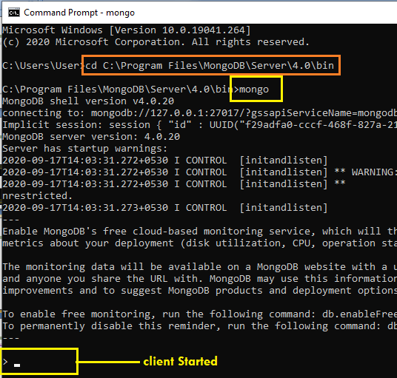

**open mongodb server and client by typing below**

**First Terminal : mongodb server**

In command prompt start server by typing below

cd C:\Users\Student\Desktop\MongoDB\Server\3.4\bin>mongod --storageEngine=mmapv1 --dbpath="d:\data\db"

the folders data and db has to be created in drive d

**Second Terminal : mongodbclient - start**

In command prompt start client by typing below

cd C:\Users\Student\Desktop\MongoDB\Server\3.4\bin>mongo

copy the files login.html,server.js,dbmodule inside nodedb

**Third Terminal:**

Cd d:/nodedb

d:\nodedb>npm init

d:\nodedb>npm install

9.In terminal d:\nodedb>npm install mongojs

10.In terminal d:\nodedb>npm install mongodb

11.Run server.js ..now the server will be started [ node server.js]

12.Run login.html

Typescript:

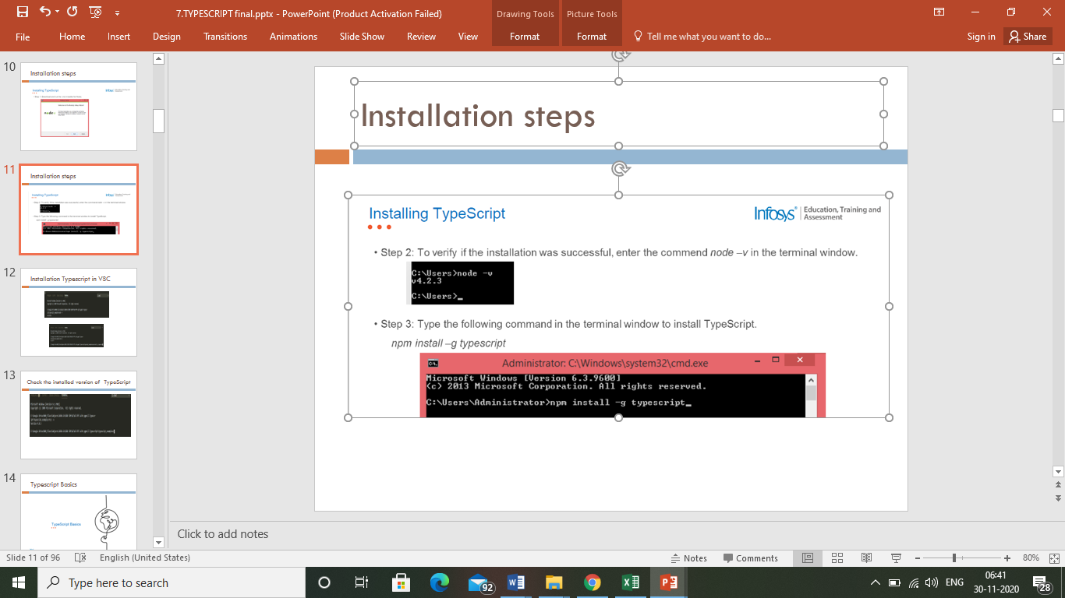

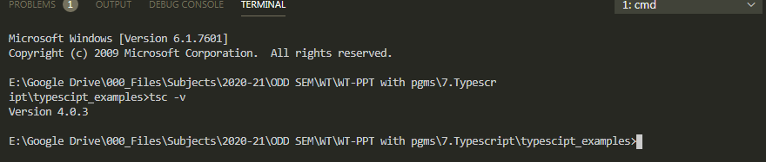

Angular:

